­­



|  |
| --- |
| **MATHEMATICS DEPARTMENT**  **Year 12 Methods - Test Number 3 - 2016  Integration and the Binomial Distribution**  **Resource Free** |

**Name: _______________________________________ Teacher: __________________**

**Marks: 21**

**Time Allowed: 15 minutes**

**Instructions:** You are NOT allowed ANY Calculators or notes.

You have been supplied with a formula sheet.

_________________________________________________________________________

1 Which statement is not true?

A 

B 

C 

D 

E  [2 marks]

2 An approximation to  using 10 centred rectangles is given by:

A 0.2 × [03 + 0.23 + 0.43 + 0.63 + 0.83 + 13 + 1.23 + 1.43 + 1.63 + 1.83]

B 0.2 × [0.23 + 0.43 + 0.63 + 0.83 + 13 + 1.23 + 1.43 + 1.63 + 1.83 + 23]

C 0.1 ×[0.13 + 0.33 + 0.53 + 0.73 + 0.93 + 1.13 + 1.33 + 1.53 + 1.73 + 1.93]

D 0.2 ×[0.13 + 0.33 + 0.53 + 0.73 + 0.93 + 1.13 + 1.33 + 1.53 + 1.73 + 1.93]

E 0.2 × [0.253 + 0.53 + 0.753 + 13 + 1.253 + 1.53 + 1.753 + 23]

[2 marks]

3 The area of the figure below is given by:

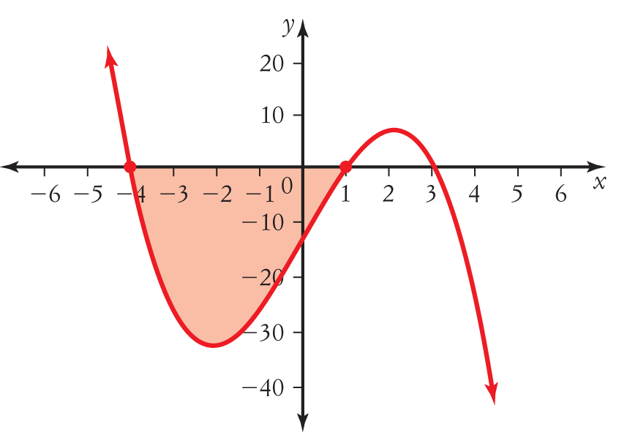

A 

B 

C 

D 

E  [2 marks]

4 Which statement would find the approximate area under the curve y = 4 - x2 using the rectangles below.

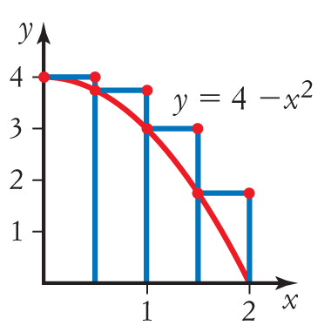

A 0.5 × [4 – 02 + 4 – 0.52 + 4 – 12 + 4 – 1.52]

B 0.5 × [02 + 0.52 + 12 + 1.52]

C 0.5 × [0.52 – 4 + 12 – 4 + 1.52 – 4 + 22 – 4]

D 0.5 × [4 – 0.52 + 12 + 1.52 + 22]

E 0.5 × [4 – 0.52 + 4 – 12 + 4 – 1.52 + 4 – 22] [2 marks]

5 The value of the definite integral  is:

A –

B 

C 

D 

E –

**[2 marks**]

6  =

A 

B 

C 5f ′(x) + 3

D 

E  [2 marks]

7 The shaded area below can be written as:

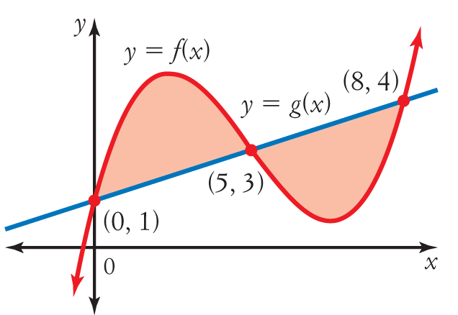

A 

B 

C 

D 

E  [2 marks]

8 =

A 64

B 48

C 40

D 24

E 12 [2 marks]

9 If the derivative of is 2(x − 3) , then the antiderivative of (x − 3) is:

A  + *c*

B (x − 3) 

C  + *c*

D 2(x − 3) 

E  + *c* [2 marks]

1. Find the exact probability that when a six-sided die is rolled four times a number less than 5 occurs on exactly two occasions.

[3 marks]

Additional Working Space Below:

***END OF RF TEST***